

Capstone Project Phase A

**Understanding of AI-Based Recruitment Outcomes**

[GitHub](https://github.com/YoavKatz99/Understanding-of-AI-Based-Recruitment-Outcomes)

Project Number

**25-1-R-6**

Supervisors:

Dr. Julia Sheidin

Dr. Avital Shulner Tal

Alin Migdalovich [alin.migdalovich@e.braude.ac.il](mailto:alin.migdalovich@e.braude.ac.il)

Yoav Katz [yoav.katz@e.braude.ac.il](mailto:yoav.katz@e.braude.ac.il)

# 

# 

1. **Introduction…………………………………………………………… 2**
2. **Background and Related Work……………………………………… 3**
   1. **Recruiting process and parameters………………………... 3**
   2. **Chosen dataset………………………………………………. 5**
   3. **XAI: textual and visual explanations……………………… 5**

**2.3.1 Visual data explanations methods………………………………. 5**

**2.3.2 Textual data explanations methods……………………………… 8**

**2.3.3 Textual vs. Visual explanations…………………………………. 11**

* 1. **XAI tools……………………………………………………. 11**
  2. **Summary……………………………………………………. 12**

**3. Expected Achievements…………………………………………… 13**

**4. Research Process…………………………………………………... 14**

**4.1. XAI type selection……………………………………………. 14**

**4.2. Next Phase Process – activity diagram……………………… 15**

**4.3 Architecture/tools……………………………………………… 15**

**4.3.1 Backend………………………………………………… 15**

**4.3.2 Frontend………………………………………………. 16**

**4.4 GUI ……………………………………………………………. 17**

**4.5 Challenges………………………………………………………. 17**

**5. Evaluation Plan………………………………………………………….18**

# 

# 

# 

# 

# **Chapter 1**

# **Introduction**

The recruitment process in the software industry is a challenge for both job seekers and recruiters. Candidates often struggle to showcase their skills and experience in the best way. Many resumes are poorly written or don’t match the job descriptions well, which causes strong candidates to be rejected even when they are qualified [5].

On the other hand, recruiters have a hard time too. Each job opening brings in hundreds of resumes, and recruiters only have a few minutes to review each one. They often focus on specific parts like education and experience, but this can lead to missing great candidates. Automated tools, while helpful, sometimes reject good resumes because they don’t understand the context well enough [5]. This gap between candidates and recruiters shows how much we need a better solution.

Current tools like resume templates or professional writing services give some help, but they are limited. Many automated systems don’t explain how they make decisions, which makes it hard for people to trust them [6].

In this research project, we aim to investigate ways to represent the data contained in CVs. This includes designing clear, intuitive visual and textual explanations of the data so candidates will be able to understand how they should create a proper CV.

We hope that the impact of this project will be significant for job seekers, who will get useful insights to make their resumes stronger and better suited for specific roles and have a better chance to showcase their potential. In the end, our goal is to help candidates to create more efficient CVs.

# 

# 

# **Chapter 2**

# **Background and Related Work**

**2.1 Recruiting Process and Parameters**

Recruitment plays a critical role in organizational success, with HR departments tasked with identifying the most suitable candidates from pools of applicants [1]. HR departments face several challenges, including managing the vast quantity of applications [4] and ensuring fair and unbiased candidate evaluations [7]. Traditional processes often result in qualified candidates being overlooked due to human error or biases, while the need for speed in filling positions can lead to suboptimal hiring decisions [4]. However, with the advent of AI, the dynamics of recruitment have shifted dramatically. AI-driven systems now provide recruiters with powerful tools (such as) to streamline candidate selection by automating resume evaluations, skill matching, and even clustering candidates based on their suitability for specific roles [4].

For example, [**HireVue**](https://www.hirevue.com/) uses AI to analyze resumes in conjunction with video interviews. Its CV analysis component focuses on matching qualifications with job requirements and scoring candidates based on experience and skills.

According to Koivunen et al. (2019), recruitment decision-making is often conceptualized as a process involving four main stages: establishing requirements, identifying alternatives, comparing alternatives, and selecting the most suitable match [2]. The initial stage defining what constitutes a good match. Organizations frequently lack clarity about their goals and long-term needs, leading to opportunistic hiring decisions that may result in suboptimal outcomes [2].

Identifying alternatives is identifying and attracting individuals who would meet the requirements [2]. Platforms like LinkedIn and other e-recruitment tools are widely used to attract and identify candidates. However, these tools often fail to capture the deeper, unique qualities of candidates, such as personality traits, which are essential for team long-term success. Moreover, the reliance on algorithms to pre-screen candidates may limit diversity and reinforce biases, further complicating the decision-making process [2].

Comparing alternatives is assessing the candidates in relation to the requirements and each other [2]. Decision-makers often rely on superficial information like job titles or personal impressions about suitable people, which provide an incomplete picture of a candidate’s capabilities [2]. This stage is also influenced by self-reported description, where candidates present themselves in ways they believe align with recruiters' expectations.

The final stage, selecting the most suitable candidate, is frequently constrained by time pressures and organizational practices that prioritize speed over quality [2]. To address these challenges, iterative approaches, including trial periods or phased hiring processes, are recommended to ensure better alignment between candidates and organizational needs [2].

Technology has the potential to enhance decision-making in HR by addressing some of these challenges. Existing job technologies have been found to bring issues to the hiring decision-making such as biased hiring, lack of job match quality and cognitive overload [2].

Key recruitment parameters often begin with academic qualifications. Education credentials, including relevant coursework and GPA, serve as foundational criteria in the evaluation process [5]. A strong academic background is frequently associated with cognitive ability, motivation, and work ethic [5]. However, it is not the sole determinant of employability. Professional experience—whether through internships, previous roles, or industry exposure—holds even greater weight in predicting a candidate’s potential contributions [5].

Another critical parameter is the alignment of a candidate’s skill set with job requirements. AI systems such as IntelCV leverage predefined patterns to extract and compare skills from resumes against those outlined in job descriptions [4]. By applying clustering techniques, these systems not only enhance accuracy but also provide recruiters with actionable insights into the quality of matches within their applicant pools [4].

Technology has the potential to enhance decision-making in HR by addressing some of these challenges. Existing job technologies have been found to bring issues to the hiring decision-making, such as biased hiring, lack of job match quality, and cognitive overload [2].

**2.2** [**Chosen Dataset**](https://www.kaggle.com/datasets/sauravsolanki/hire-a-perfect-machine-learning-engineer/data)

The dataset that we intend to work with is entitled: “Hire A Machine Learning Engineer” or “HireAMLE” which is owned by Saurav Solanki. Our dataset contains 150 CVs of various titles such as ML Engineer, MERN Stack Developer, AWS Engineer, Computer Vision Engineer, etc. The CVs include unique id, job roles, preferred skills and education. The CVs are divided into test and train groups. The dataset was designed to predict the match percentage for a specific ML job description which is also included in the dataset. For each CV in the training group, Match percentages are given. For the test group, we can predict the match percentages using compatible analysis code, provided by the user “REMI LEGRAND” on Kaggle.com.

The code evaluates candidate CVs to find the best match for a job based on their technical skills. It begins with pre-processing of lemmatize and removing all the stopwords. It checks each CV for specific skills from a predefined list, counts how many skills match, and calculates a score. The score considers how many skills a CV matches compared to the average and gives extra points to CVs with many skills. A chart shows how often each skill appears in the CVs. Finally, the CVs are ranked by their scores, and the results are compared to an existing dataset for validation.

**2.3 Explanations for Multi-dimensional Data**

**2.3.1 Visual Data Explanations Methods**

Zenkert et al.(2018) introduces The Multidimensional Knowledge Representation (MKR) as a knowledge base representation structure for multidimensional information from unstructured data in large-scale knowledge graphs. Therefore, the state of the art in the fields of knowledge graphs, big data analytics and related methods have been considered and reviewed [8]. The framework simplifies this process by creating targeted subsets of data by applying specific criteria, such as Sentiment Analysis or Topic Detection [8].

Visualization techniques supported by MKR include:

Tile view, which displays results as tiles of varying size and color as appears in Fig 2. These variations can reflect the type or frequency of entities, sentiments, or topics. For instance, tiles might show named entities along with corresponding images to provide a clearer understanding of the text content [8]. 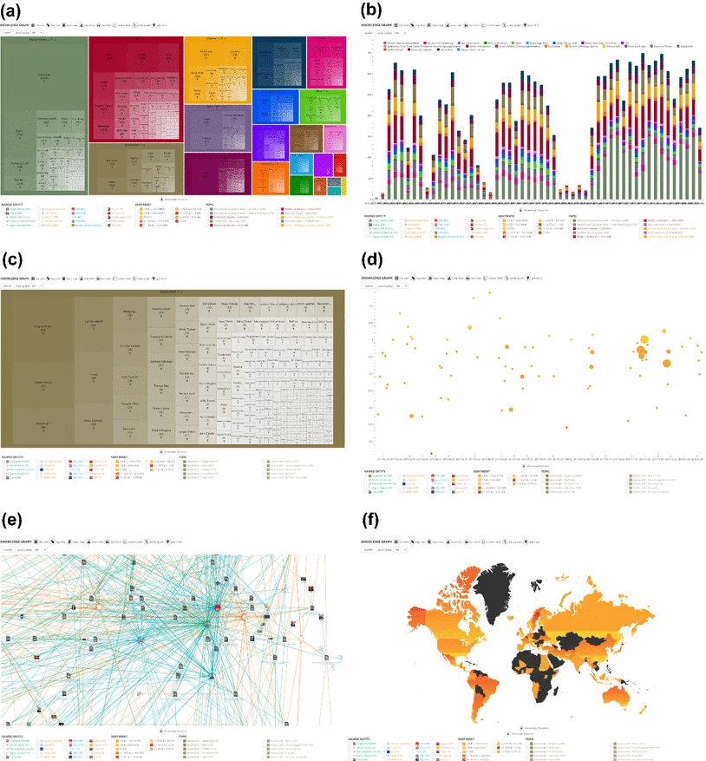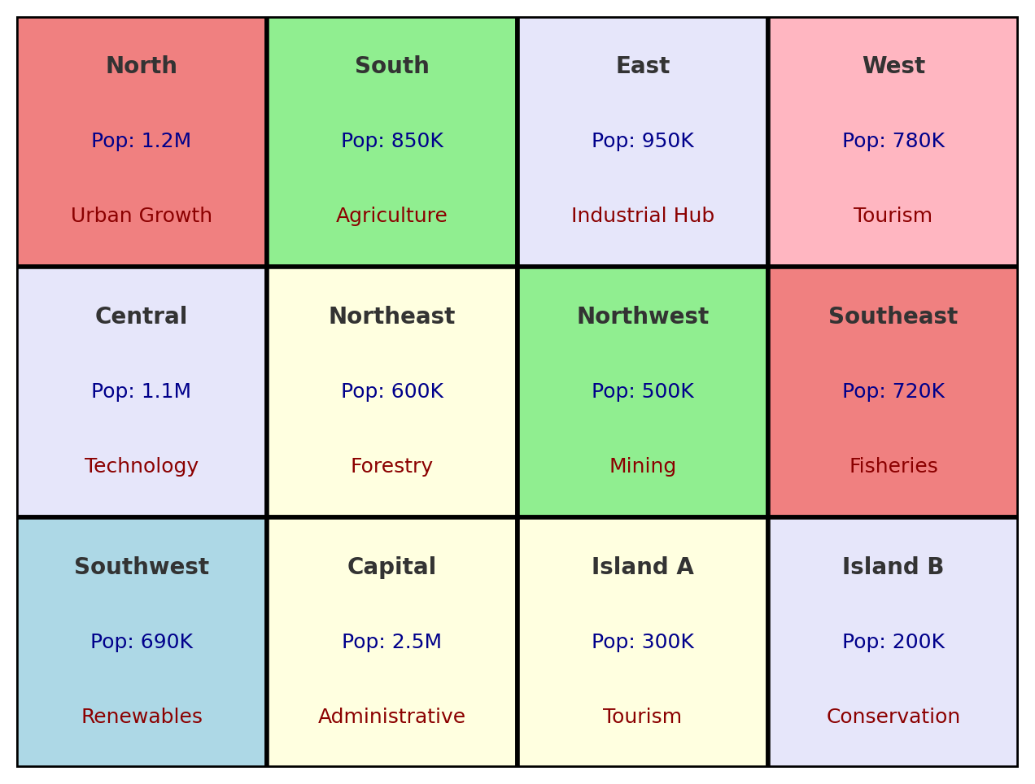

*Figure SEQ Figure \* ARABIC 2 - Tile view*

*Figure SEQ Figure \* ARABIC 1 - Bar chart [8]*

Another method is the Topic map, as seen on Fig 3, which organizes information into hierarchical levels. Each rectangle in the map represents a topic or subtopic, with its size and color indicating the frequency or significance of the related data [8].



*Figure SEQ Figure \* ARABIC 3 - Topic map with subtopics [8]*

Statistical graphs include area charts, bar charts (Fig 1), and scatter charts. Area charts represent time-series data as stacked areas to show trends, such as the rise and fall of certain topics. Bar charts compare discrete data, which is represented horizontally or vertically at different given discrete values such as time stamps. Scatter charts plot data points across two dimensions, with additional information like size and color used to indicate further details, such as entity frequency (Fig 4)[8].



*Figure SEQ Figure \* ARABIC 4 - Scatter chart [8]*

The entity graph focuses on relationships between entities (Fig 5), using nodes and edges to map these connections. This type of visualization is particularly useful for showing semantic relationships. It helps illustrate how entities relate to each other within the data [8].



*Figure SEQ Figure \* ARABIC 5 - Entity graph [8]*

Finally, map graphs are used to visualize geographic data by highlighting locations mentioned in the text. As seen on Fig 6, These graphs color parts of a map, such as countries or regions, based on their relevance or frequency in the dataset [8].

*Figure SEQ Figure \* ARABIC 6 - Map graph [8]*

MKR supports transformation between visualization types, allowing data to be represented in different formats based on the analysis context [8].

Midway (2020) can add a few rules to make better scientific visuals. For instance, Color is an important tool. Choose color schemes that work for people with color blindness and that still look good in black and white. This ensures the visual is clear for everyone [3]. Including uncertainty in visuals is also important. Things like error bars or shaded areas can show how reliable the data is. Midway warns against using uncertainty measures without explaining them clearly, as this can confuse readers [3]. Small multiples, or side-by-side comparisons of similar visuals, are a great way to show differences between groups or variables. This method makes comparisons easier [3].

**2.3.2 Textual Data Explanations Methods**

Word clouds remain popular due to their simplicity, offering a graphical description of word frequency. Their effectiveness lies in the quick identification of prominent themes within a dataset, although they lack context, which may lead to oversimplifications (Fig 7) [9].

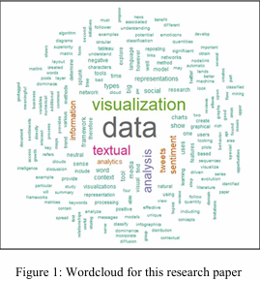

*Figure SEQ Figure \* ARABIC 7 - Word cloud [12]*

Network diagrams are another tool for visualizing relationships within textual data. These diagrams map, as seen on Fig 8, connections between entities, such as concepts in academic texts. The strength of network diagrams lies in their ability to highlight complex relationships that would be difficult to see in text alone. For example, in social network analysis, these diagrams can show how individuals or groups interact and influence each other [9].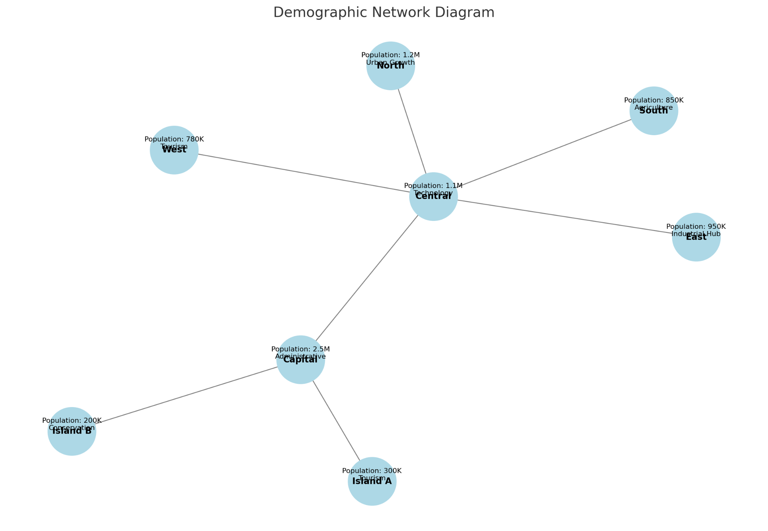

*Figure SEQ Figure \* ARABIC 8 - Network diagram*

#### Hierarchical tree diagrams (Fig 9) describe data in a tree-like structure, representing layers such as chapters, sections, and subsections in a document. They are useful in organizing and presenting data with nested relationships, enabling users to grasp the overall structure of a text at a glance [9].

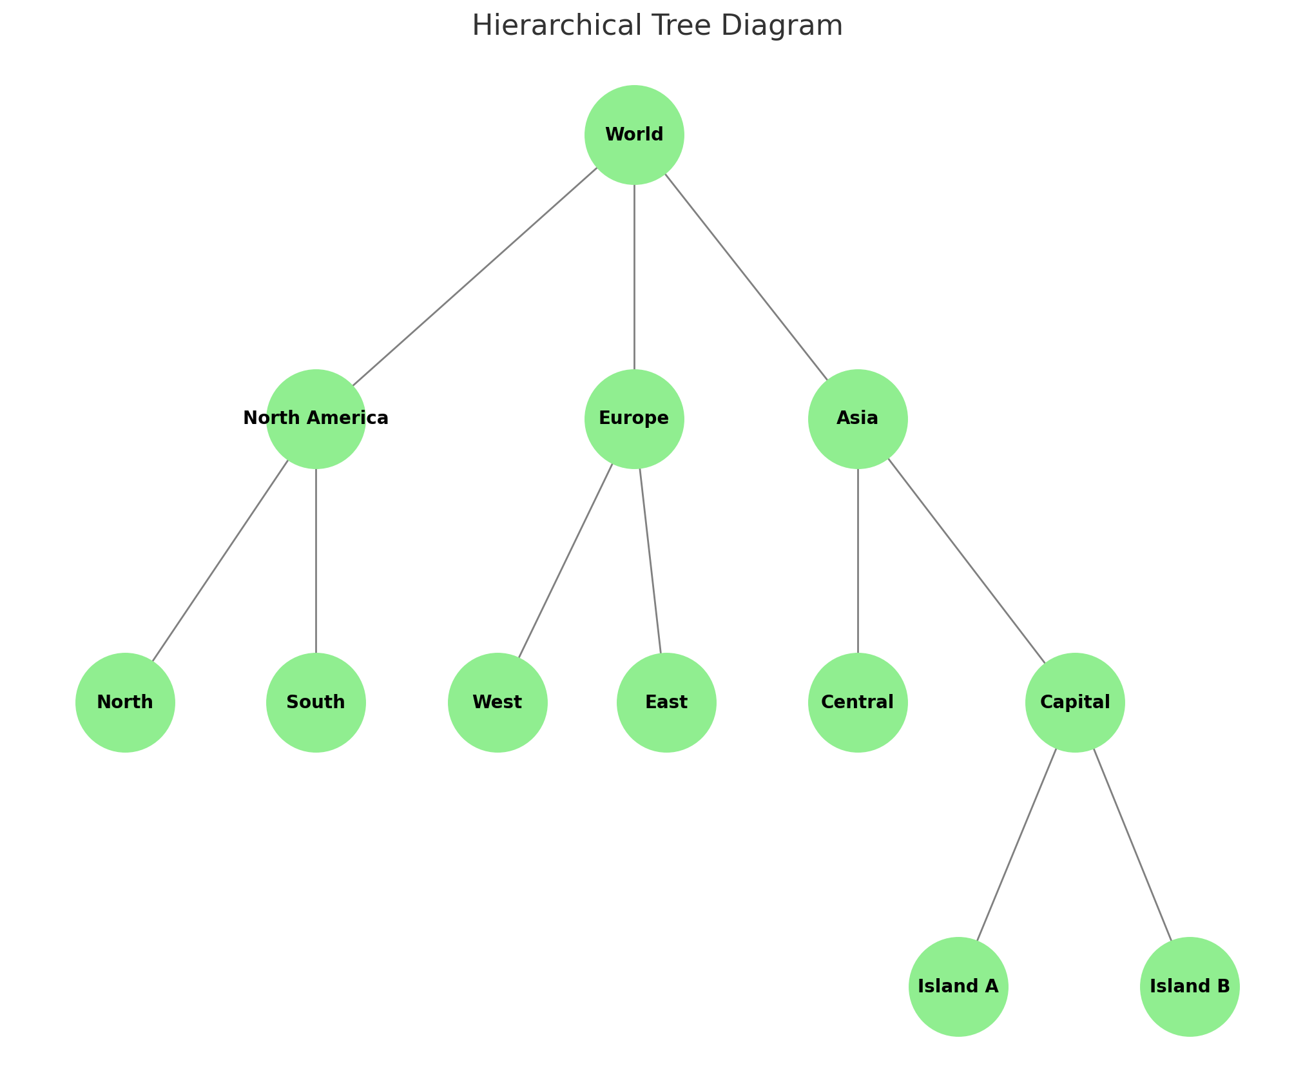

*Figure SEQ Figure \* ARABIC 9 - Hierarchical tree diagram*

Topic maps is a visualization tool that illustrates the connections between various topics within a dataset. These maps are particularly useful in topic modeling, an approach in textual analysis that seeks to identify underlying topics in a body of text [9]. Topic maps allow researchers to explore themes and how they connect and affect each other, offering deep insights into the structure and meaning of textual data [9].

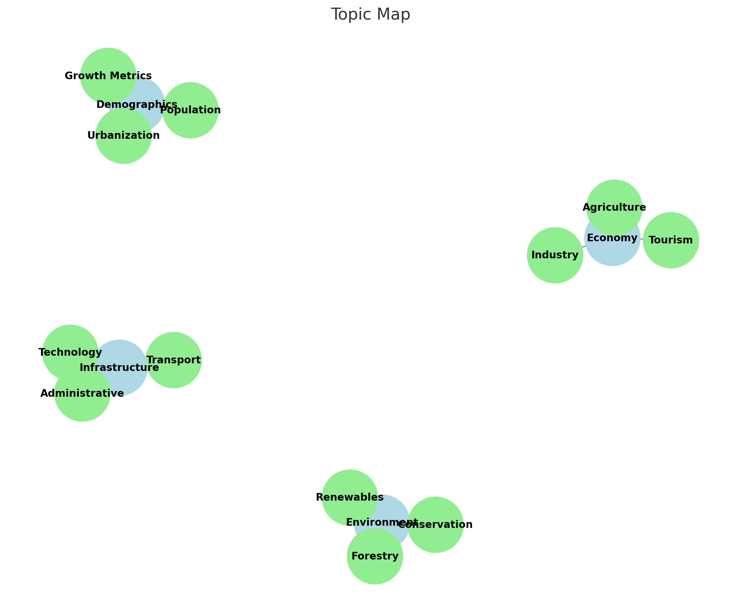

*Figure SEQ Figure \* ARABIC 10 - Topic map*

Interactive dashboards bring a dynamic element to textual analysis by allowing users to explore data in an intuitive way. Dashboards enable filtering and sorting to uncover deeper insights. For instance, a researcher analyzing survey data can use an interactive dashboard to explore responses based on different demographic groups, facilitating a more nuanced understanding of the results [9].

**2.3.3 Textual Data vs. Visual Data Explanations**

Visual explanations excel at displaying item connections but demand greater user engagement for interpretation [10]. Textual explanations were consistently rated as more persuasive and easier to understand compared to visual formats [10]. Visual explanations were perceived as less convincing, particularly by users without prior familiarity with complex visualizations [10]. This suggests that while visual formats can be powerful, their utility is limited by the user's ability to interpret the presented graphics. User familiarity with visualizations had a positive correlation with the acceptance of visual formats but did not exceed the overall preference for textual explanations [10].

**2.4 XAI Tools**

Explainable Artificial Intelligence (XAI) methods are critical in understanding how AI systems make decisions, particularly when dealing with complex models often perceived as "black boxes" [6].

The paper elaborates on SHAP (SHapley Additive exPlanations) and its reliance on game theory to assign importance to each feature in a dataset [6]. SHAP determines the contribution of each feature to the model's output using Shapley values, which provides a fair distribution of importance by calculating the marginal contributions of all feature subsets.

Similarly, LIME (Local Interpretable Model-Agnostic Explanations) creates interpretable surrogate models that approximate the predictions of a complex AI system locally (around a specific instance of interest) [6]. LIME confuses the input data and observes how the predictions change, thereby identifying the features that are most influential in the decision-making process. This method is particularly valuable for explaining specific decisions of the AI model, such as why a particular prediction was made, in a straightforward and understandable way [6].

Counterfactual explanations are used in supervised machine learning when a model gives an undesired prediction for a specific data point. They identify the minimal changes to the input features that would result in a desired model output [11].

**2.5 Summary**

In conclusion, effective recruitment is essential for organizational success, but HR departments face challenges such as handling large applicant pools, ensuring unbiased evaluations, and making fast yet valid hiring decisions. AI-driven solutions like HireVue offer tools to address these concerns by automating processes: from resume analysis and skill matching to candidate clustering. The four-stage framework (requirements, alternatives, comparison, and selection) highlights the need for clear job descriptions. Various data explanation methods,—including visual (tile views, bar charts, entity graphs) and textual (word clouds, network diagrams, topic maps), offer ways to explore and communicate insights. Explainable AI techniques, such as SHAP, LIME, and Counterfactual explanations further enhance transparency by clarifying AI models results.

# 

# 

# 

# 

# 

# **Chapter 3**

# **Expected Achievements**

As part of this project, we aim to conduct an in-depth analysis of the collected dataset, focusing on the parameters that affect job seekers, such as education, skills, work experience, and match percentages for specific roles. This analysis will help us identify how these factors influence a candidate’s chances of being matched to a job and uncover patterns that can guide job seekers in improving their resumes.

Next, we will integrate SHAP, LIME and Counterfactual Explanations into the existing matching algorithm. These tools will provide explanations of how the match percentage is calculated and why a specific CV receives a specific match score. We will utilize these advanced tools to present the data, both visually and textually. This will include the use of statistical graphs, mappings, and other visualization techniques to ensure a clear and intuitive representation of the findings.

Finally, we will evaluate the effectiveness of these explanations by gathering feedback from a relevant target audience, such as recruiters and students. This feedback will help us refine our approach and ensure the explanations are clear and valuable.

# 

# 

# **Chapter 4**

# **Research Process**

The process began with an extensive literature review, which involved examining academic and industry publications to gather insights on the challenges in the recruitment process, such as how recruiters evaluate candidates and in manual and automated screening methods. The review also looked at how visual and textual explanations can make the results more understandable. Following this, we proceeded to explore and analyze our dataset, ensuring its relevance and quality to our research objectives. Next, we shifted our focus to understand how explainable AI tools like SHAP, LIME, and Counterfactual explanations. Finally, it focused on finding ways to combine these insights to create a system that presents and explains the match percentage of CVs.

**4.1. XAI type selection**

We've decided to select SHAP since it's more accurate, and supports an explanation of the model and the decision making over a specific CV. In addition, it has tools such as Force Plot and Summary Plot visual graphs, which is part of what we are focusing on in this project.

We will also use LIME to provide quick, interpretable explanations for individual predictions in a model-agnostic manner. It has the ability to create a simple, interpretable surrogate model around the specific prediction. Additionally, it supports diverse data types like text, tabular, and images.

Finally, we will run a Counterfactual explanations tool on our dataset. Counterfactual explanations provide insights by answering "what if" scenarios. This approach is particularly valuable in applications where end-users need to know what adjustments could lead to a positive decision. Counterfactual explanations are intuitive, user-centric, and focus on transparency by highlighting model behavior in specific contexts. They are also useful for ensuring fairness, as they can uncover biased decision patterns in the model.

**4.2. Next Phase Process**

The following activity diagram presents the next stages of our project: 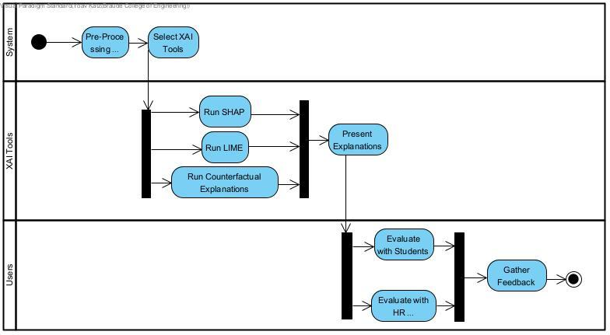

**4.3 Architecture and tools**

The following tools and technologies will be used in our project:

### **4.3.1. Backend (AI and Data Processing)**

#### Programming Language:

* Python: Widely used for machine learning, data processing, and API integration.

#### AI Models:

* ML/DL Frameworks: TensorFlow or PyTorch: For custom machine learning models (e.g., semantic matching, clustering candidates)**.**

#### Database:

* Google Firebase (NoSQL Database): to store resumes and any related documents while providing secure access

### **4.3.2. Frontend (User Interaction and Visualization)**

#### Programming Language:

* JavaScript/TypeScript: Standard for interactive web applications.

#### Frameworks/Libraries:

* React.js: For building responsive, component-based web interfaces.
* Dash: For integrating data visualizations with Python backend directly.
* D3.js: For creating advanced, customizable data visualizations (e.g., entity graphs, tile views).

#### Visualization Tools:

* Plotly: For interactive dashboards and graphs.
* Chart.js: For lightweight charts (e.g., bar charts, pie charts).
* Echarts: For more complex visualizations like scatter plots or heatmaps.

#### Styling:

* Tailwind CSS: For responsive and visually appealing designs.

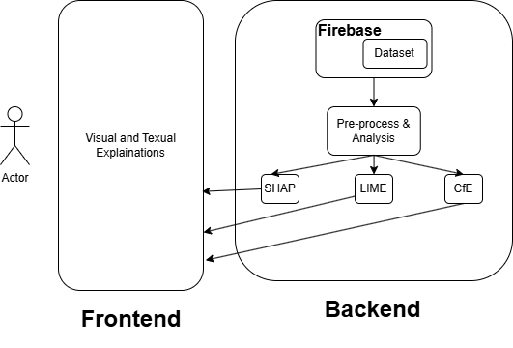

**4.4** [**GUI**](https://www.canva.com/design/DAGcdv_kX-U/cMAwqU9V9JI19TND08D3sQ/edit?utm_content=DAGcdv_kX-U&utm_campaign=designshare&utm_medium=link2&utm_source=sharebutton)

**4.5 Challenges**

**4.5.1 Difficulty in finding relevant academic literature**

One of the challenges we faced was finding articles that covered both the technical side of our project and the HR side. While there’s a lot of research on tools like SHAP and LIME and how they work, there weren’t many studies about the use of SHAP, LIME or Coutnerfactual explanations in resume matching or recruitment.

**4.5.2 Familiarize with SHAP, LIME and Counterfactual Explanations**

Neither of these tools had been part of our prior studies, and their functionality requires research and experimentation. We discovered that SHAP, LIME and Counterfactual Explanations use different approaches to generating explanations global vs. local which added to the complexity of integrating them with our matching algorithm. Moreover, we need to understand the technical limitations of these tools.

**4.5.3 Explaining Why the Tool Made Its Decision**

It’s hard to explain why the tool decided on specific match percentages because the process it uses is very complex. Tools like SHAP, LIME and Counterfactual Explanations help show which parts of the resume, like skills or education, influenced the result, but their explanations are often technical and not easy to understand. The challenge is figuring out how to take these detailed, complicated outputs and turn them into clear, simple explanations that users can actually use. If we’re not careful, the explanations might end up being too confusing or too vague to be helpful.

**5 Evaluation Plan**

To ensure the system operates correctly and as intended, we will evaluate it through the following steps:

1. Execute the testing plan.

| Test ID | Description | Expected Result | Precondition Comments | Comments |
| --- | --- | --- | --- | --- |
| 1 | Matching a CV to a job description and calculating a match percentage | The system will display a clear match percentage based on the analyzed parameters. | A job description is entered, and a matching CV is uploaded. | Local |
| 2 | |  | | --- | |  |  |  | | --- | | Generating a textual explanation | | The system will provide a simple and clear textual explanation of how the match percentage was calculated. | A successful match process has been completed. | Ensure the explanation is easy to understand for non-technical users. |
| 3 | Generating a visual explanation | The system will produce visual graphs or charts to illustrate the key factors affecting the match percentage. | The match analysis is completed successfully. | Evaluate the clarity and usability of the visual outputs. |
| 5 | Generating SHAP explanations | SHAP-based explanations will highlight the most impactful factors contributing to the match. | Match analysis is completed. | .Ensure SHAP results are intuitive and align with user expectations. |
| 6 | Generating LIME explanations | LIME will generate localized explanations for specific CV-job matches. | Match analysis is completed. | Test on both high and low match percentages for variety. |
| 7 | Generating Counterfactual explanations | The system will provide "what-if" scenarios by showing the minimal changes needed to improve a match percentage. | Match analysis is completed. | Test for clarity in counterfactual outputs and relevance of suggested changes. |
| 8 | Data analysis | The system will rank multiple CVs by match percentage for a single job description. | A job description is entered, and a matching CV is uploaded. | Global |

1. Have the system used by real users: students and HR recruiters.

This test plan outlines the strategy for testing the usability, effectiveness, and clarity of the system in providing explanations and visualizations related to CV evaluation. This test plan aims to ensure that the system meets its requirements and performs as expected.

User evaluation will help us see how people understand these explanations and visualizations. We want to ask them questions like “Which of the explanations was the most understandable?”, “Which of the visualizations were most understood?” or “Did you understand what are the most important parameters in CVs?”.

For the purpose of evaluating our results, we will gather the feedback by questionnaires and interviews with the users, and in the end, we will analyze their results and draw conclusions.

### **References**

[1] Sürücü, S., Küçük, B., & Aydın, M. K. (2024). An example of the application of artificial intelligence models in human resources processes. Afyon Kocatepe Üniversitesi İktisadi ve İdari Bilimler Fakültesi Dergisi, 26(Özel Sayı), 101-116.‏

[2] Koivunen, S., Olsson, T., Olshannikova, E., & Lindberg, A. (2019). Understanding decision-making in recruitment: Opportunities and challenges for information technology. Proceedings of the ACM on human-computer interaction, 3(GROUP), 1-22.‏

[3] Midway, S. R. (2020). Principles of effective data visualization. Patterns, 1(9).‏

[4] Moumita Kabir, "IntelCV: An Intelligent Skilled Resume Selection Method for Job Purposes," United International University, 2024.

[5] Pina, A.; Petersheim, C.; Cherian, J.; Lahey, J.N.; Alexander, G.; Hammond, T., "Using Machine Learning with Eye-Tracking Data to Predict if a Recruiter Will Approve a Resume," Machine Learning & Knowledge Extraction, 2023.

[6] Angelov, P. P., Soares, E. A., Jiang, R., Arnold, N. I., & Atkinson, P. M. (2021). Explainable artificial intelligence: An analytical review. *WIREs Data Mining and Knowledge Discovery*, 11(5), e1424.<https://doi.org/10.1002/widm.1424>

[7] Barrak, A., Zouaq, A., & Adams, B. (2021). Toward a traceable, explainable, and fair JD/Resume recommendation system. *Research Proposal*, Polytechnique Montréal, Québec, Canada.

[8] Zenkert, J., Klahold, A., & Fathi, M. (2018). Knowledge discovery in multidimensional knowledge representation framework: An integrative approach for the visualization of text analytics results. Iran Journal of Computer Science, 1(4), 199-216.‏

[9] Milev, P. (2023). The Role of Data Visualization in Enhancing Textual Analysis. Trakia Journal of Sciences, 21(1), 248-253.‏

[10] Kouki, P., Schaffer, J., Pujara, J., O'Donovan, J., & Getoor, L. (2019, March). Personalized explanations for hybrid recommender systems. In Proceedings of the 24th international conference on intelligent user interfaces (pp. 379-390).‏

[11] Verma, S., Dickerson, J., & Hines, K. (2020). Counterfactual explanations for machine learning: A review. arXiv preprint arXiv:2010.10596, 2, 1.‏

[12] Conner, C., Samuel, J., Kretinin, A., Samuel, Y., & Nadeau, L. (2020). A picture for the words! textual visualization in big data analytics. *arXiv preprint arXiv:2005.07849*.‏